Fortismere School

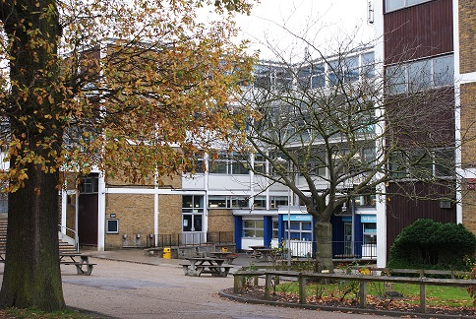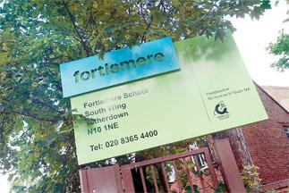

Fortismere School is a high achieving, mixed, foundation secondary school in Muswell Hill, North London. The 2017-18 season is our 3rd season of Vex and 2nd season of Vex EDR. During our first ever season of vex in the Vex IQ Bankshot challenge we managed to qualify for the world finals in Kentucky however were unable to attend due to funding issues. In our second year, (last season) we started our first two Vex EDR teams and once again had great success managing to secure second place for skills in all the UK and having large success in the UK nationals - making it all the way to the quarter finals.

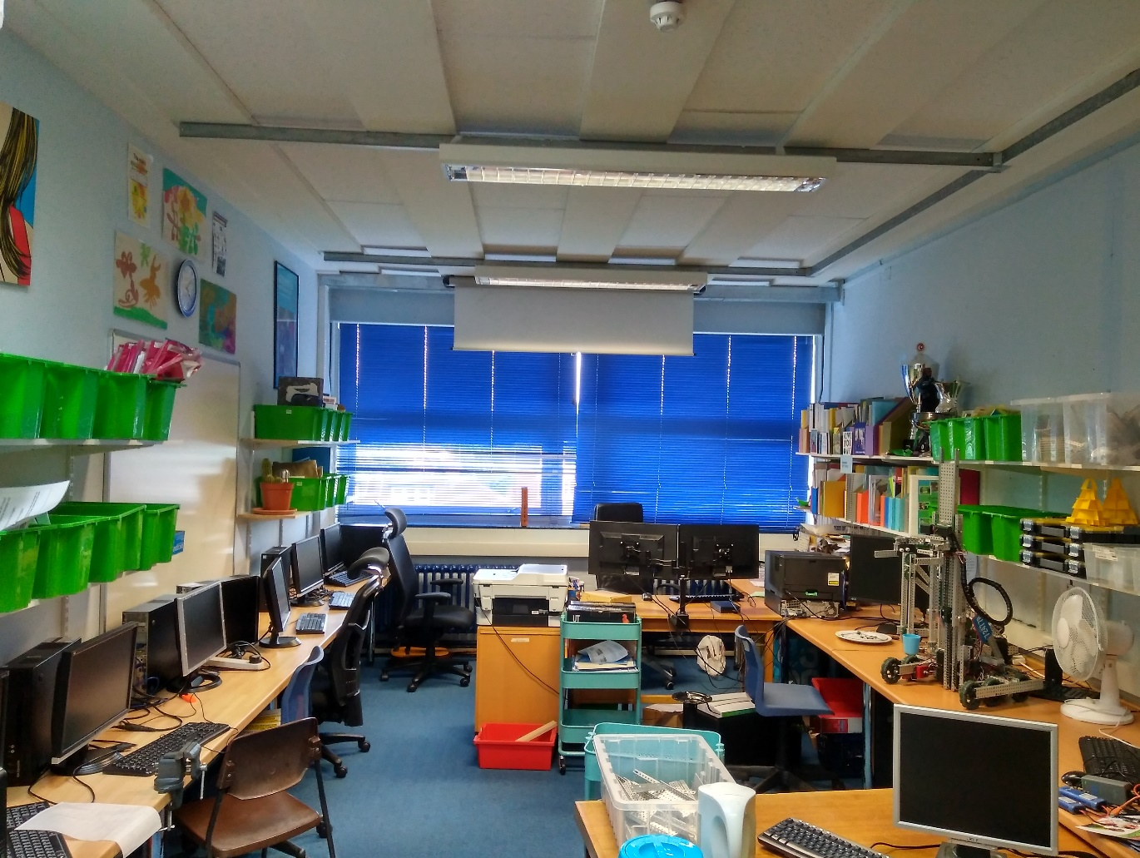

Most of the robot construction takes place here, in the Vex workshop and computing office. Our team members come during break, lunch, free periods, and after school to work on the robots resulting in a constant work-flow. We have all the different materials and tools sorted into various storage methods around the workshop, allowing for easy access and at the same time keeping the room tidy.

Meet the Staff

# Mr M Yakup Lead Mentor/Coach

# C:\Users\admin\AppData\Local\Microsoft\Windows\INetCache\Content.Word\IMG_20170915_133525.jpg

Mr Yakup is head of Enterprise at Fortismere, encompassing ICT, DT, Economics and Business, each of which are extremely useful skills to have in regards to the competition. Mr Yakup is very dedicated, spending lots of his own time after school and on weekends ensuring we have everything we need and we all are taken to competitions safely.

He acts as a great role model, offering tips and advice whenever needed.

# Mr B Ovaloyu Programming Mentor

# Image result for empty profile picture

For whoever comes with us to a comp